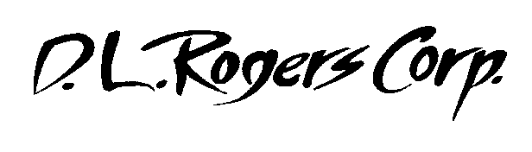

5013 Davis Blvd. · North Richland Hills, TX 76180
800/880-0765 - 817/428-2077 · Fax: 817/428-7254

August 25, 2016

Steve,

I just wanted to send you a letter thanking you for the amazing “Keynote” performance you gave at our convention! Our over 750 attendees were treated to a performance that had them laughing, intensely listening and even shedding a tear or two during your presentation. Your ability to connect to the audience and to “draw them in” to you story is extremely admirable!

There is no doubt you believe in what you write because you definitely “Making a difference” in people’s lives as was evident by the standing ovation you received at the end of you time with us. No one at this meeting nor our prior meeting have received higher rating than you did!

Thanks for energizing our team and sending them back home with great information to live by!

Thanks for all you do!

James Junkin

Chief Operating Officer

